**Harness Fundamentals**

* Designed to be a Controller and Worker type model.
* Can be installed on-prem Enterprise self-managed platform.
* External source – communicates to Harness platform - communicates to Harness Delegates.
* Delegates is the bridge b\w your local infra and Harness platform.
* Hierarchy – One account has multiple Orgs, which has multiple projects.

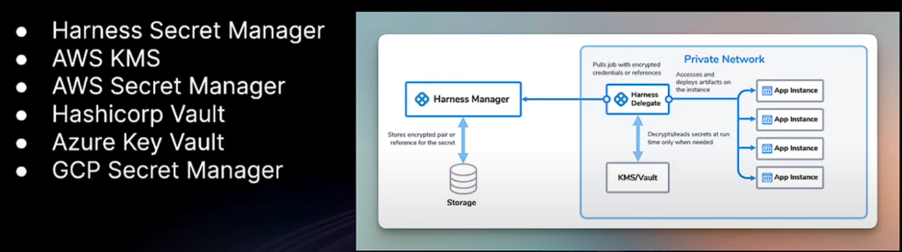

**Delegates**

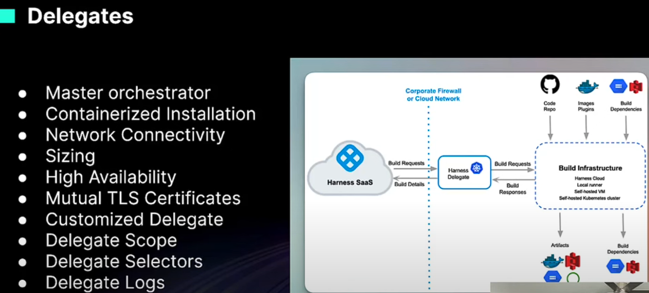

We can isolate delegate in DMZ kind of zone as well.

Delegate scoping, it can be scoped to specific projects, organisations or even to specific parts of Harness platform.

Delegate installation is straight forward from the UI.

**Connectors**

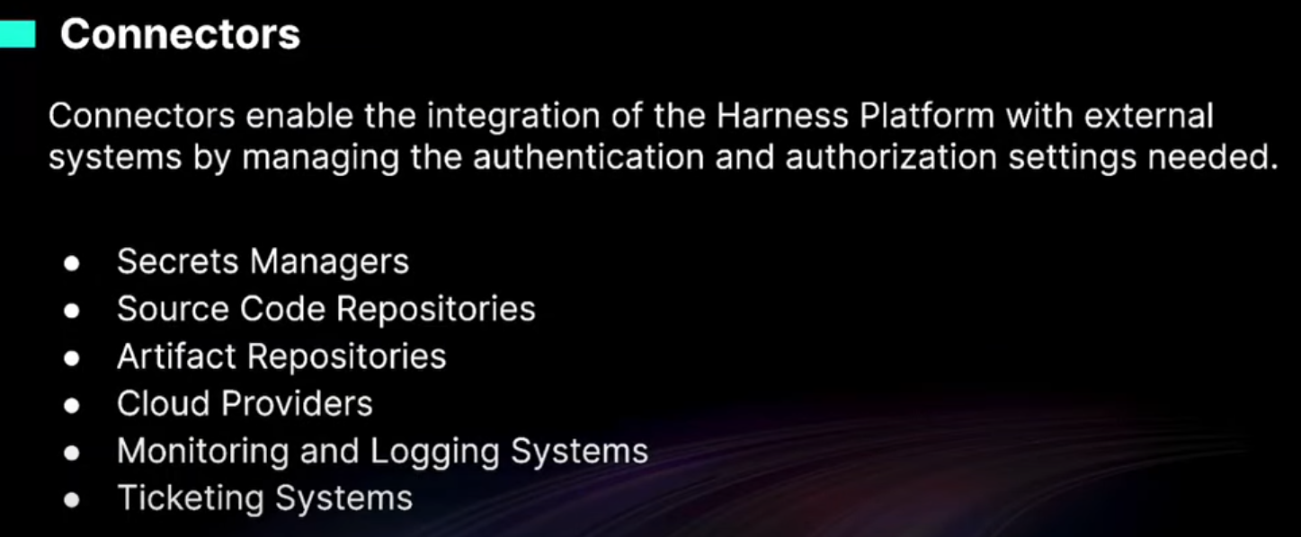

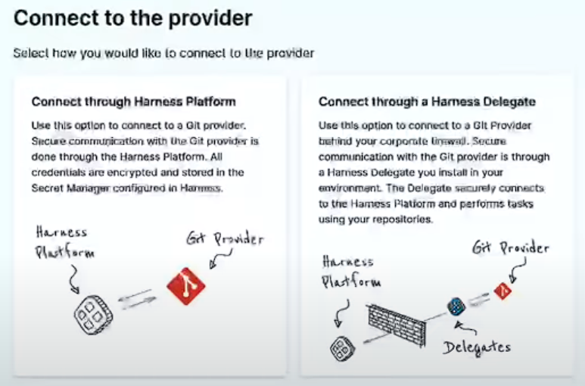

**Pipelines**

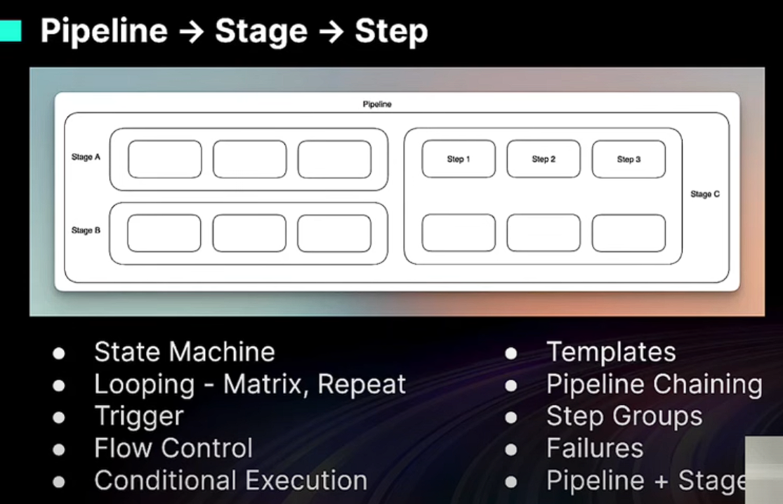

You can build the pipeline in the visual mode and the configuration code.

Generally it is via the Config mode, using the YAML editor

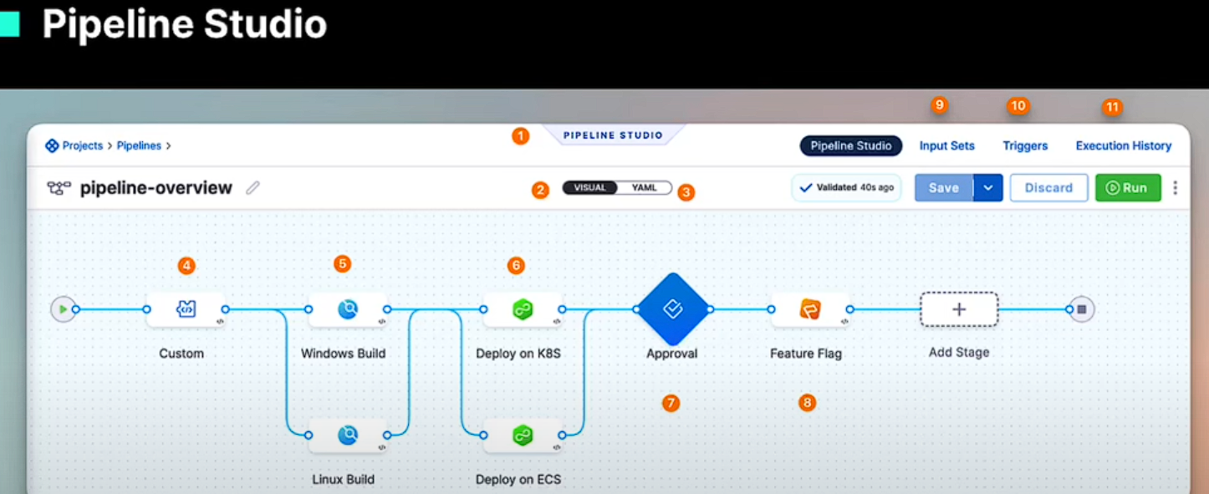

Approval Process

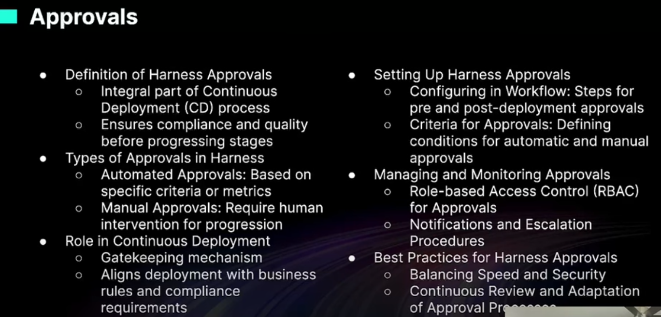

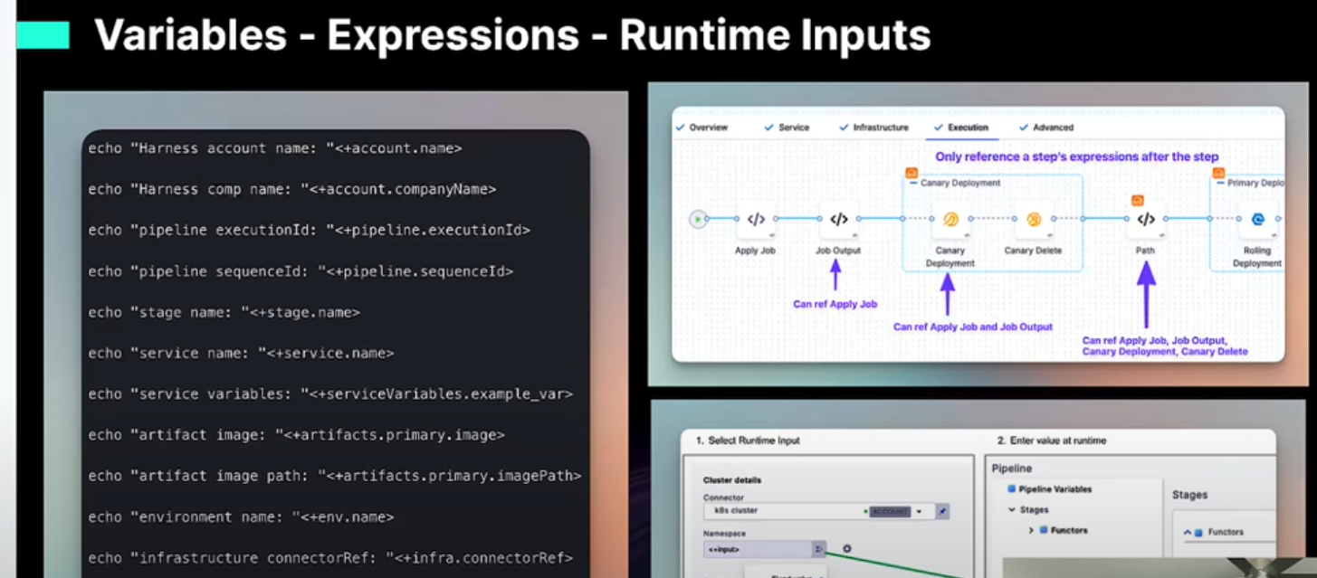

Run time inputs – these are dynamic, not fixed.

Expressions – these are fixed values.

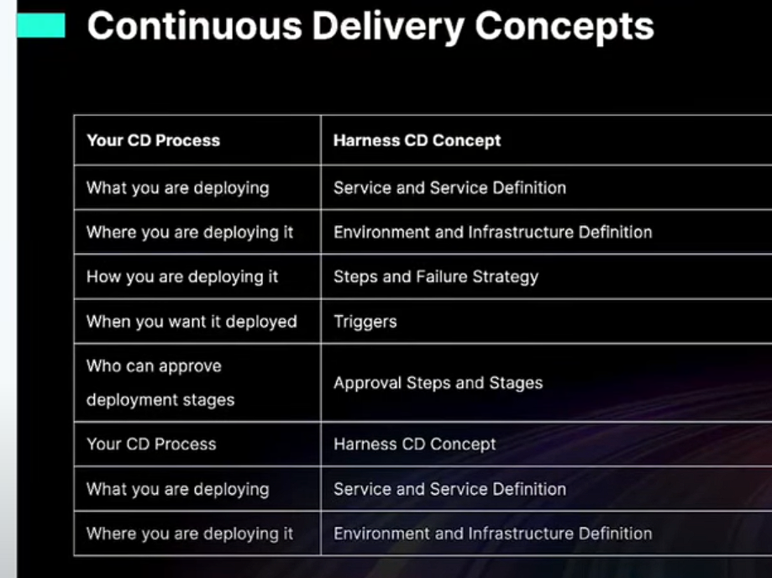

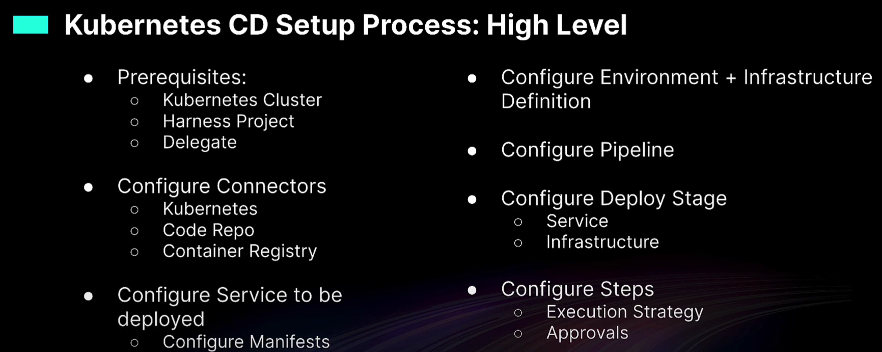

Services represent the ‘What’ of the deployment.

Harness also supports service deployments using Helm chart deployments, it doesn’t need to be plain vanilla YAML format.

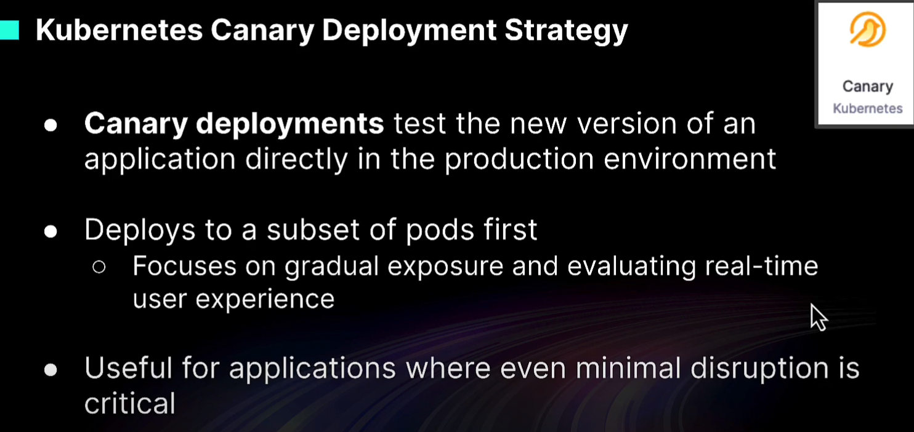

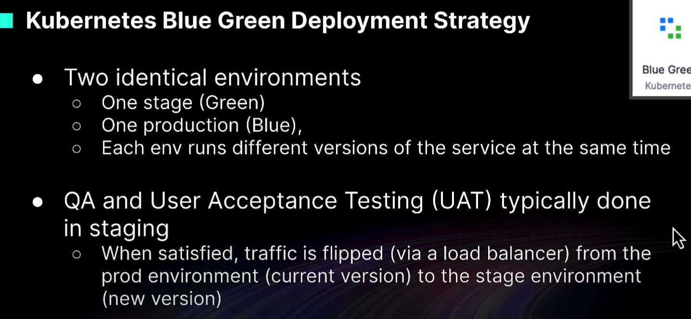

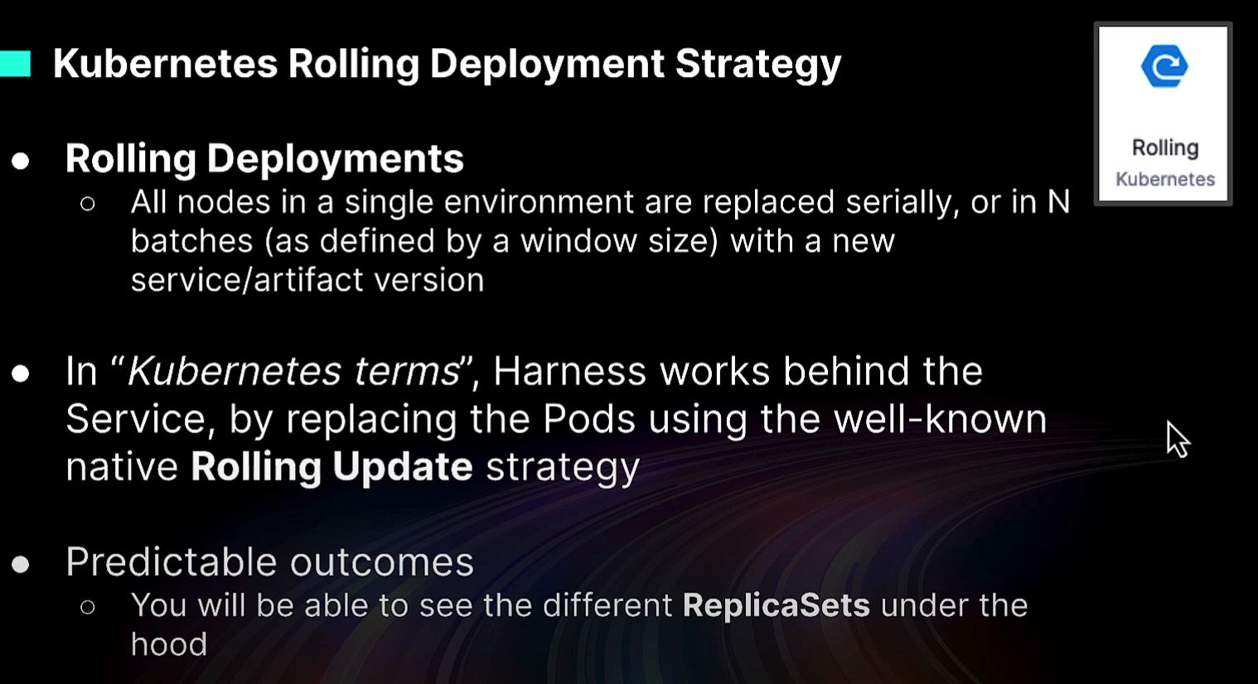

Rolling deployment focusses more on the infrastructure side of things. Eg: replacing N number of nodes in batches.

